
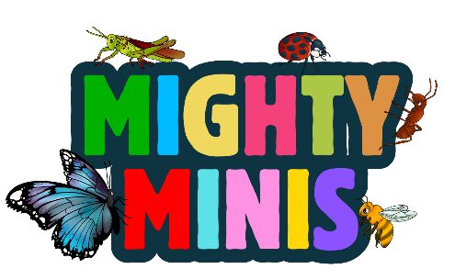
Day 5

MEMORY VERSE:
“Two are better than one.”
Ecclesiastes 4:9
THEME:
SWARM AS ONE
BIBLE STORY:
Mighty Army
Joshua 3 & 6

Locusts are swarming this puzzle! Cut out each piece carefully and see if you can put it back together as one.

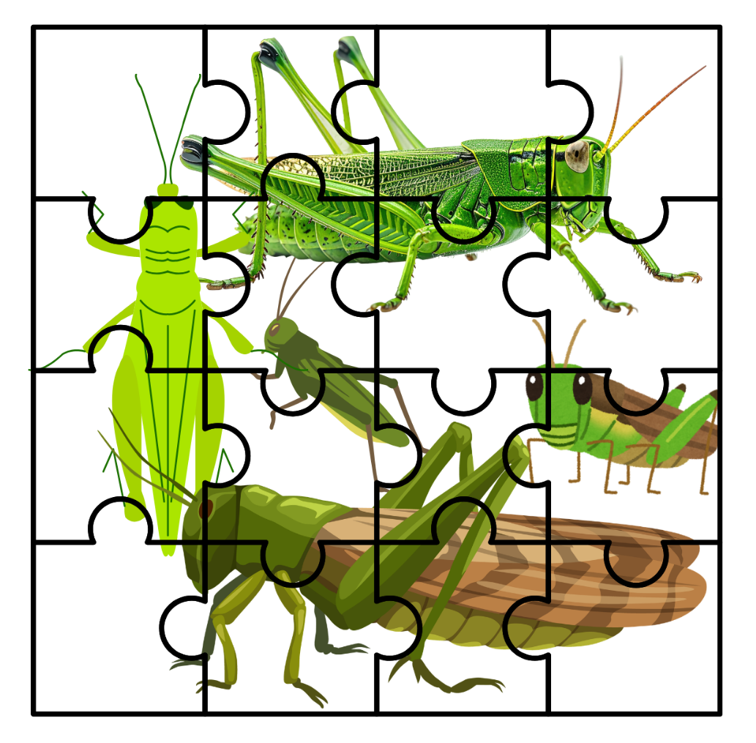

Day 5

MEMORY VERSE:
“Two are better than one.”
Ecclesiastes 4:9
THEME:
SWARM AS ONE
BIBLE STORY:
Mighty Army
Joshua 3 & 6

Locusts are swarming this puzzle! Cut out each piece carefully and see if you can put it back together as one.

